Car Rental System
Using oops concepts

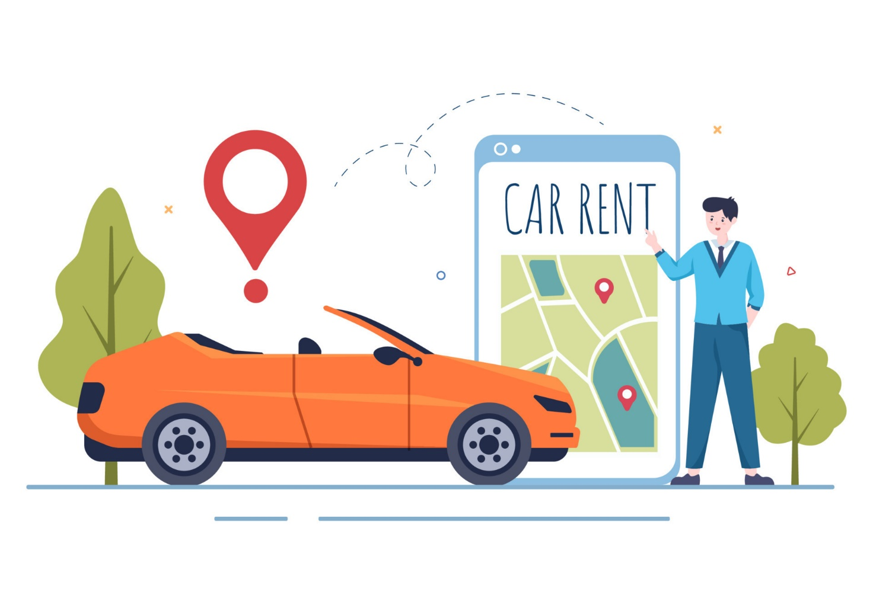

Content

1. Introduction

2.Acknowledgments

3. Obejected-Oriented Programming Concepts

4. Functionality

5. System Feature

6. Project Structure

7. Implementation Details

8. Future Enhancements

9. Conclusion

1. Introduction:

The Car Rental System project aims to develop a robust and user-friendly application for managing car rental services. Utilizing Object-Oriented Programming (OOPs) concepts in Java, the system provides functionalities for customers to rent cars, view available vehicles, bookings.

Nowadays, most of the people prefer car for their trip.
Because car journey to any trip with our family or friends gives happiness and makes us to feel comfortable.
Many advantages in car rental system rather than using own cars for their journey.
2. Acknowledgments:
We would like to express our gratitude to all stakeholders involved in the project, including developers, testers, and end-users, for their valuable contributions and feedback throughout the development lifecycle. Their collaboration has been instrumental in the success of the Car Rental System project.

3. Object-Oriented Analysis and Design:

• Classes and Objects:
The system is designed using classes to represent entities such as Car, Customer, Reservation, and Administrator. Each class encapsulates data and behavior relevant to its respective entity.

• Inheritance:
Inheritance is employed to establish hierarchical relationships between classes. For instance, the Car class may inherit common properties and methods from a more general Vehicle class.

• Polymorphism:
Polymorphism allows methods to be implemented differently in derived classes. This concept can be applied, for example, in calculating rental fees based on different car types.

• Encapsulation:
Encapsulation is utilized to restrict access to certain data and methods within classes, ensuring data integrity and promoting modularity.

• Abstraction:
Abstraction is employed to model real-world entities as simplified representations in code. For instance, the Car class abstracts away details such as engine specifications and manufacturing processes.

4. Functionality:
• Adding Cars:
The system allows adding standard cars, SUVs, and luxury cars to the rental inventory.
• Renting Cars:
Customers can rent available cars by providing their details and selecting a car from the available options.
• Returning Cars:
Customers can return rented cars, and the system marks the car as available for future rentals.
• Menu Display:
The system displays a menu for users to choose between renting a car, returning a car, or exiting the program.
• Price Calculation:
Rental prices are calculated based on the base price per day of each car and the number of rental days.

5. System Features:

• Car Management:
Administrators can add new cars, update existing vehicle information, and remove cars from the rental fleet.

• Booking Management:
Customers can search for available cars based on criteria such as location, date, and vehicle type. They can make view their booking history.

• Rental Pricing:
The system calculates rental fees based on factors such as car type, duration of rental, and any additional services requested.

6. Project Structure:

The project consists of several Java classes:
• Main Class (Main.java):
Entry point of the program. It initializes the CarRent system, creates instances of various cars, that are defined by owner and add these cars to rental system class using addCar method and invoke menu method of CarRent class to start Rental system.

• Functionality Class (Main.java):
In this class we use method named :-
- getValidAadharNo: To get valid Aadhar number of 12 digits using Exception Handling , otherwise it will ask again to enter valid input from user.
- getValidMobileNo: To get valid Mobile number of 10 digits using Exception Handling , otherwise it will ask again to enter valid input from user.
- getValidDays: To get valid no of days for renting a car using Exception Handling, otherwise it will ask again to enter valid input from user.
• CarRent Class (CarRent.java):
Manages the rental system. It contains following methods :
CarRent:- It is a constructor used to initialize array list of cars, customer and rent arraylist that is used to add car, customer and rented car details of car and customer respectively.
returnCar:- It’s a method which take object of car in parameter and remove from rent array list .
• Customer Class (Customer.java):
In this class we use constructor to initialize data of customers.
And use getters to return details of customers which will be shown at the time of renting and returning a car.
• Rent Class (Rent.java):
Represents a rental transaction between a customer and a car. It stores the car, customer, and the number of rental days.
• Car Class (Car.java):
Represents a generic car. It implements the Rentable interface and provides methods to get car details, calculate rental prices(overriding), mark a car as rented, and mark a car as available.
• SUV Class (SUV.java):
Inherits from the Car class and represents an SUV vehicle.
• Luxury Class (Luxury.java):
Inherits from the Car class and represents a luxury car.
7. Implementation Details:
• Car Class:
Contains attributes such as make, model, year, and methods for retrieving vehicle details.
• Customer Class:
Stores customer information and methods for booking history.
• Rental Class:
Manages, calculates rental costs based on vehicle type and duration.

8. Future Enhancements:

• Integration with GUI (Graphical User Interface) for better user interaction.

• Integration with online payment gateways for seamless transactions.
• Implementation of a recommendation system based on customer preferences.
• Integration with GPS for tracking vehicle locations
and route optimization.

9. Conclusion:

The Car Rental System project demonstrates the Object-Oriented Programming concepts in Java to develop a comprehensive and scalable solution for managing car rental system. By leveraging OOPs principles such as encapsulation, inheritance, polymorphism, and abstraction, the system achieves modularity, flexibility, and maintainability.

Code Design

This Java program simulates a car rental system where customers can rent and return cars. Let's break down the key components and functionalities provided by the code:
Key Classes and Interfaces
• Rentable Interface:
This interface defines a method calculatePriceOfRent(int noOfDays) which is implemented by the Car class to calculate the rental price based on the number of days.
• Car Class:
Represents a basic car with properties like carId, brand, model, basePricePerDay, and isAvailable. It implements the Rentable interface to calculate rental prices and has methods rent() and returnCar() to mark the availability of the car.
• SUV Class:
Extends the Car class to represent SUV vehicles. It inherits properties and methods from Car.
• Customer Class:
Represents a customer with properties like customerId, name, aadhar, mobileNo, and address.
• Rent Class:
Represents a rental transaction associating a Car with a Customer for a specified number of days.
• CarRent Class:
Manages the car rental system. It includes methods to add cars and customers, rent a car to a customer, return a car, and display a menu for interaction.
Main Class (Main)
• Main Method:
Creates an instance of CarRent (car rental system) and initializes it with some cars (Car and SUV instances).
• User Interaction:
Invokes the menu() method of CarRent, which presents a menu-driven interface for users to rent or return cars.
Functionality Overview
• Renting a Car:
Prompts the user to enter their details (name, mobileNo, aadhar, address).
Displays available cars and prompts the user to select one.
Calculates the total rental price based on the number of days.
Confirms the car's availability.

• Returning a Car:
Prompts the user to enter the car ID they wish to return.
Verifies if the car is eligible for return (not available) and retrieves associated rental details.
Confirms the return and updates the car's availability.

CODE

import java.util.*;

interface Rentable {
double calculatePriceOfRent(int noOfDays);
}

class Car implements Rentable {
// creatiing a class of car that have following property
private String carId;
private String brand;
private String model;
private double basePricePerDay;
private boolean Available;

/*
all property are declared a private because we don't show it outside the
class (Encapsulation)
*/
public Car(String carId, String brand, String model, double basePricePerDay) {
this.carId = carId;
this.brand = brand;
this.model = model;
this.basePricePerDay = basePricePerDay;
this.Available = true;
}

// using getter for getting value
public String getCarId() {
return carId;

}

public boolean Available() {
return Available;
}

public String getBrand() {
return brand;

}

public String getModel() {
return model;
}

public double getbasePricePerDay() {
return basePricePerDay;
}

@Override
public double calculatePriceOfRent(int noOfDay) {
return (double) noOfDay * basePricePerDay;
}

// using a method what will mark false if car is not available
public void rent() {
Available = false;
}

// this method will mark true if car is returned;
public void returnCar() {
Available = true;
}

}

class SUV extends Car {
// Using Inheritance and using same car class to add Suv vehicle
public SUV(String carId, String brand, String model, double basePricePerDay) {
super(carId, brand, model, basePricePerDay);
}

}

class luxury extends Car {
public luxury(String carId, String brand, String model, double basePricePerDay) {
super(carId, brand, model, basePricePerDay);
}
}

class Rent {
private Car car;
private Customer customer;
private int noOfDays;

// using constructor to initialize the Rent values
public Rent(Car car, Customer customer, int days) {
this.car = car;
this.customer = customer;
this.noOfDays = days;
}

public Car getCar() {
return car;
}

public Customer getCustomer() {
return customer;
}

public int days() {
return noOfDays;
}

}

class Customer {
private String customerId;
private String name;
private long aadhar;
private long mobileNo;
private String address;

// Using constructor to initialize the value or property of customer
public Customer(String customerId, String name, long aadhar, long mobileNo, String address) {
this.customerId = customerId;
this.name = name;
this.aadhar = aadhar;
this.mobileNo = mobileNo;
this.address = address;

}

// Using getter to returning value or property or details of customer
public String getCustomerId() {
return this.customerId;
}

public String getName() {
return this.name;
}

public String getAddress() {
return this.address;
}

public long getAadhar() {
return this.aadhar;
}

public long getMobile() {
return this.mobileNo;
}
}

// class presenting a car rental system
class CarRent {
private List<Car> cars; // listing cars available for rent
private List<Customer> customer; // listing customers who have rented cars
private List<Rent> rent; // listing rent details for cars

// Constructor
public CarRent() {
cars = new ArrayList<>();
customer = new ArrayList<>();
rent = new ArrayList<>();
}

// Method to add a car to the list of available cars
public void addCar(Car car) {
this.cars.add(car);
}

// Method to add a customer to the list of customers
public void addCustomer(Customer customer) {
this.customer.add(customer);
}

// Method to rent a car to a customer for a specified number of days
public void rentCar(Car car, Customer customer, int days) {
if (car.Available()) {
car.rent();
rent.add(new Rent(car, customer, days));

} else {
System.out.println(" Car is not available for rent");
}
}

// Method to return a car to the list of available cars
public void returnCar(Car car) {
car.returnCar();
Rent rentCartoRemove = null;

for (Rent r : rent) {
if (r.getCar() == car) {
rentCartoRemove = r;
break;
}
}
if (rentCartoRemove != null) {
rent.remove(rentCartoRemove);
System.out.println("Car returned successfully");

} else {
// car.returnCar();
System.out.println("Car was not rented");

}
}

// Method to display the menu for the car rental system
public void menu() {
try (Scanner sc = new Scanner(System.in)) {
while (true) {
System.out.println("------ Car Rental System ------");
System.out.println("Enter your Choice");
System.out.println("1. Rent a Car");
System.out.println("2. Return a Car");
System.out.println("3. Exit");
System.out.print("Enter your choice: ");

String choice = sc.nextLine();
System.out.println(""); // next line

if (choice.equals("1")) {
System.out.println(" --- Rent a Car ---");
System.out.println("Enter your name: ");
String customerName = sc.nextLine();

System.out.println("Enter mobile no");
long mobileNo = sc.nextLong();

System.out.println("Enter AADHAR no");
long aadhar = sc.nextLong();
System.out.println("Enter your address");
sc.nextLine();
String address = sc.nextLine();
System.out.println("Available Car");
// Print available cars and details
System.out.println("Car Id" + " - " + "Car name (price/day)");
System.out.println("---------------------------------------");

// prints available cars for rent
for (Car car : cars) {
if (car.Available()) {
System.out.println(car.getCarId() + "-" + car.getBrand() + " " + car.getModel() + " " + "("
+ car.getbasePricePerDay() + ")");

}
}
System.out.println("\n Enter the Car ID you want to rent Else Enter 0 for no rent or exit");
String carId = sc.nextLine();
if (carId.equalsIgnoreCase("0")) {
break;
}
System.out.println("Enter the number of days you want forn rent");
int rentDays = sc.nextInt();
// System.out.println("");
sc.nextLine();

Customer newCustomer = new Customer("CUS" + (customer.size() + 1), customerName, aadhar, mobileNo,
address);
addCustomer(newCustomer);

Car selectedCar = null;
for (Car car : cars) {
if (car.getCarId().equalsIgnoreCase(carId) && car.Available()) {
selectedCar = car;
break;
}
}

if (selectedCar != null) {
double totalPrice = selectedCar.calculatePriceOfRent(rentDays);
System.out.println("\n---- Rental Information ----");
System.out.println("Customer ID: " + newCustomer.getCustomerId());
System.out.println("Customer Name: " + newCustomer.getName());
System.out.println("Selected Car: " + selectedCar.getBrand() + " " + selectedCar.getModel());
System.out.println("Rental Days: " + rentDays);
System.out.printf("Total Price: ₹ %.4f\n", totalPrice);
System.out.println("Please confirm your rent (Y/N)");
String confirm = sc.nextLine();

if (confirm.equalsIgnoreCase("Y")) {
rentCar(selectedCar, newCustomer, rentDays);
System.out.println("\n Car Rented Successfully");

} else if (confirm.equalsIgnoreCase("N")) {
System.out.println("Car Rental canceled");

}
} else {
System.out.println("\n Invalid car selection ");
}
}

else if (choice.equals("2")) {
System.out.println("\n --- Return a Car ---");
System.out.println("Enter Car ID you want to return");
// System.out.println();
// sc.nextLine();
String carId = sc.nextLine();

Car carToReturn = null;
for (Car car : cars) {
if (car.getCarId().equalsIgnoreCase(carId) && !car.Available()) {
carToReturn = car;
break;
}
}
if (carToReturn != null) {
Customer customer = null;
for (Rent r : rent) {
if (r.getCar() == carToReturn) {
customer = r.getCustomer();
break;
}
}
if (customer != null) {
returnCar(carToReturn);
System.out.println("Car Returned Successfully by");
System.out.println("Customer Id: " + customer.getCustomerId());
System.out.println("Customer Name: " + customer.getName());
System.out.println("Customer Mobile no: " + (long) customer.getMobile());
System.out.println("Customer AADHAR: " + (long) customer.getAadhar());
System.out.println("Customer address: " + customer.getAddress());
}

else {
System.out.println("Car was not rented or rental information is missing");

}
} else {
System.out.println("Invalid car ID or car is not rented");
}
}

else if (choice.equals("3")) {
break;
}

else {
System.out.println("Invalid choice. Please enter a valid choice");
}

}
}
System.out.println("\n Thanks you for using the Car Rental System");
}
}

public class JavaProject {
public static void main(String[] args) {
CarRent rentalSystem = new CarRent();

Car car1 = new Car("C01", "Toyota", "Camry", 600.0); // Different base price per day for each car
Car car2 = new Car("C02", "Honda", "Accord", 700.0);
Car car3 = new Car("C03", "Mahindra", "Thar", 1500.0);
Car car4 = new Car("C04", "Ford", "Mustang", 1200.0);
Car car5 = new Car("C05", "Maruti", "Suzuki", 800.0);
luxury car6 = new luxury("C06", "BMW", "X5", 2000.0);
luxury car7 = new luxury("C07", "Mercedes-Benz", "E-Class", 1800.0);
luxury car8 = new luxury("C08", "Audi", "Q7", 2200.0);
Car car9 = new Car("C09", "Nissan", "Altima", 750.0);
Car car10 = new Car("C10", "Hyundai", "Tucson", 900.0);
SUV S1 = new SUV("Suv0001", "Mahindra", "Scorpio", 1500.56);
SUV S2 = new SUV("Suv0002", "Mahindra", "Thar", 2000);

rentalSystem.addCar(car1);
rentalSystem.addCar(car2);
rentalSystem.addCar(car3);
rentalSystem.addCar(car4);
rentalSystem.addCar(car5);
rentalSystem.addCar(car6);
rentalSystem.addCar(car7);
rentalSystem.addCar(car8);
rentalSystem.addCar(car9);
rentalSystem.addCar(car10);
rentalSystem.addCar(S2);
rentalSystem.addCar(S1);

rentalSystem.menu();
}
}

OUTPUT

Renting Car
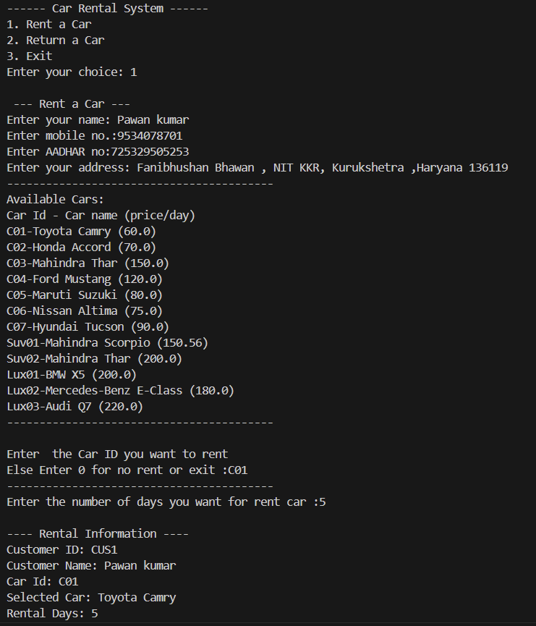

Returning car

